

ESOF

**ElasticSearch**



**Project of ESOF 2018 -- MIEIC**

**Head of CU: João Carlos Pascoal Faria**

**Class 3**

**Group 1**

* João Pedro Viveiros Franco --- up201604828 --- up201604828@fe.up.pt
* Tiago Pinho Cardoso --- up201605762 --- up201605762@fe.up.pt
* Tomás Nuno Fernandes Novo --- up201604503 --- up201604503@fe.up.pt

**Supervisor:** Filipe Alexandre Pais de Figueiredo Correia

November, 2018

**Índex**

1. ElasticSearch – The Open Source Project
   1. How alive is ElasticSearch?………..……..........3
   2. How important is ElasticSearch?………………4
   3. What is ElasticSearch good for?.........................4
   4. What are the technologies involved?..................5
2. ElasticSearch Issues…………………………..........6
   1. Issue #34127……………………………..........7

**2.1.1.** Description of the issue…………………….7

**2.1.2.** Requirements……………………………….7

**2.1.3.** Source Code Files……….………………….8

**2.1.4.** System Architecture………………………..8

**2.1.5.** Design of the fix………….………………...8

**2.2.** Issue #34609…………………………………...9

**2.2.1.** Description of the issue…………………….9

**2.2.2.** Requirements……………………………….9

**2.2.3.** Source Code Files……….………………….9

**2.2.4.** System Architecture………………………10

**2.2.5.** Design of the fix………….……………….11

1. **ElasticSearch - The Open Source Project**
   1. **How alive is ElasticSearch?**

**ElasticSearch** was born in 2004 and since then it has been growing, specially the community that works on it. This community is very active. There are **1,103 contributors** and **1,508 open issues**. Until now, there are already **16.138 closed issues**, confirming that ElasticSearch has been one of the most interesting projects to work on.

The search engine versions have been changing since ElasticSearch was created. It has **different versions**, with **version 6.x** being in **active development** with new features, and **version 5.x is still under support**. Older versions are inactive for around one year.

The **version 5.x is feature-freeze** and it's **only getting bug fixes** at the moment. Although the development for this version is not very active, the latest release, 5.6.12, was released at 19th September, which is recent. Moreover, some work on the next minor version, 5.6.13, is ongoing.

The development of the current public release, 6.4.x, is very active with almost daily commits. The next planned release, 6.5, is even more active, which means the **project contributors** are **actively working to improve the product**, either by tweaking existing functionality or by adding new features.

Overall, there are on average **over 100 commits weekly**.

Although the list of collaborators (core development team) is not known for this particular repository, **the Elastic organization has 129 people**. They have several repositories, thus this number is not a sufficient indicator for ElasticSearch in particular. However, considering the number of merged pull request and closed issues, **we can say there are enough people managing the project**.

Anyone interested in giving their contribution can easily do it. The project has a guideline for **contribution** with project's information and the steps to follow.

Summarizing, ElasticSearch is really alive and its life is sustained thanks to the numerous contributors who keep working on this amazing project, so we can expect an amazing lifetime for it.

* 1. **How important is ElasticSearch?**

Elastic search is a highly important tool for most companies, as it is a distributed, RESTful search and analytics engine capable of solving a growing number of use cases.

It is particularly relevant because it lets you perform and combine many types of searches — structured, unstructured, geo, metric — any way you want, allowing you to query data in various ways to obtain several important analytics.

For example, with this software you could search for all posts (social media and the likes) containing mentions of your product, then you could take those results and aggregate them by geography; you could then narrow it down to a specific country, even sort things out by date or break it down by the three main states of that region.

Thus, it ends up playing a somewhat vital role in things like datamining, data analysis and many subjects in that general area.

* 1. **What is ElasticSearch good for?**

Elasticsearch can be used to perform a lot of different use cases: "classical" full text search, analytics store, auto completer, spell checker, alerting engine, and as a general purpose document store.

It is especially good for analytics, because it integrates well with the ELK stack, and its interface is good for the REST/JSON driven configuration.

It provides a scalable search, since it scales horizontally to handle many events per second while automatically managing how indices and queries are distributed across many operations.

It also has a near real-time search, as a result of the implementation of inverted indices with finite state transducers for full-text querying, BKD tees for storing numeric and geo data and a column store for analytics.

Thus, it’s good for those seeking an engine that’s effective at quickly and dynamically searching through large amounts of data, as is the case for a search-intensive application.

* 1. **What are the technologies involved?**

**Type:** Software Service. Interaction with a REST API or Java API, with multiple Clients available: Java, Groovy, .Net, PHP, Perl, Python, Ruby.

**Languages:**

* **Java** – Main language
* **Groovy** – Used in buildSrc. There’s an issue open to replace Groovy with Java
* **AsciiDoc** – Documentation
* **YAML, JSON** – Mainly used on the REST API Specification

1. **ElasticSearch Issues**

* **Issue #34127 – Include origin information in deprecation logging**
* **Issue #34609 – SQL: add tests for RLIKE**

**2.1. Issue #34127** - <https://github.com/elastic/elasticsearch/issues/34127>

1. **Description of the Issue**

The ElasticSearch’s issue #34127 is the result of the lack of information on the deprecation logging. What happens is that the deprecation logging only logs the timestamp and the message of deprecation. The suggestion to correct it is to add more information to the DeprecationLogger of the project.

Here is the description of the issue by its submitter:

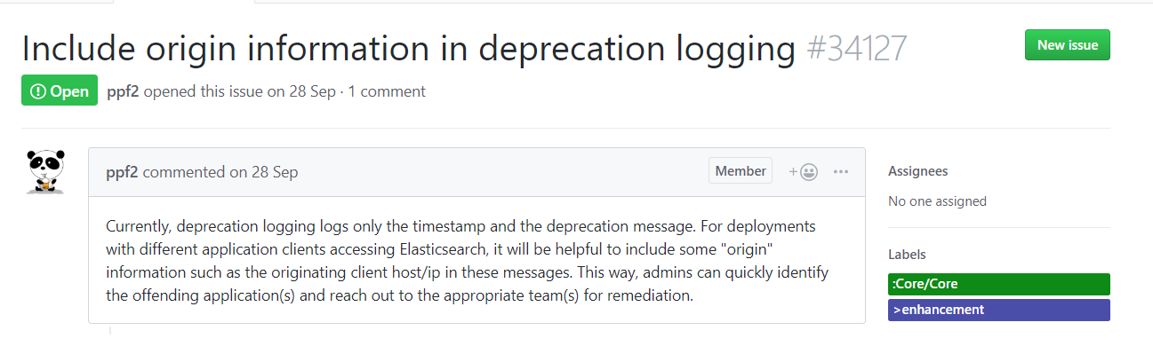

1. **Requirements**

Aiming to obtain the solution for this issue, it’s required to add more information on the deprecation message, like the hostname or IP address. We also need to know the basics of Java programming.

To solve this issue we must improve the deprecation message by adding some useful information besides the information that is given.

An example of a deprecation message is:



1. **Source code files**

The files that are directly related to #34127 issue are:

* **elasticsearch/server/src/main/java/org/elasticsearch/common/logging/DeprecationLogger.java**
* **elasticsearch/server/src/test/java/org/elasticsearch/common/logging/DeprecationLoggerTests.java**

1. **System Architecture**

After a lot of research on the open source project ElasticSearch, we achieved some knowledge of how this project works. Specifically, in this issue, the architecture has the following UML:

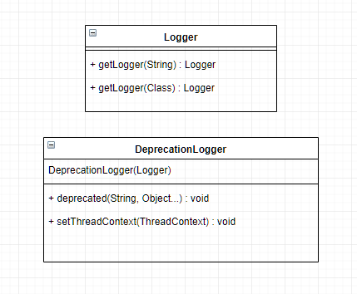

1. **Design of the fix**

To add the hostname or the IP address of the user we need to use the NetworkInterfaceand the InetAddress class of the java.net library.

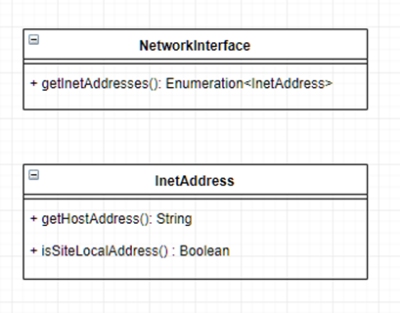

* 1. **Issue #34609** - <https://github.com/elastic/elasticsearch/issues/34609>

1. **Description of the Issue**

The #34609 ElasticSearch’s issue related to SQL language. In this issue, there is a class called **RLike** that has no tests for and it would be very positive if someone could make tests to ensure that everything runs perfectly in the meantime.

1. **Requirements**

To solve this issue we need to know the basics of SQL and how tests work in Java.

This issue requires the implementation of tests for **RLike**.

1. **Source Code Files**

Files directly related to the issue:

* **elasticsearch/x-pack/plugin/sql/src/main/java/org/elasticsearch/xpack/sql/expression/predicate/tegex/RLike.java**
* **elasticsearch/x-pack/plugin/sql/src/test/java/org/elasticsearch/xpack/sql/optimizer/OptimizerTests.java**
* **elasticsearch/x-pack/plugin/sql/qa/src/main/resources/filter.sql-spec**

Code fragments directly related to de issue:

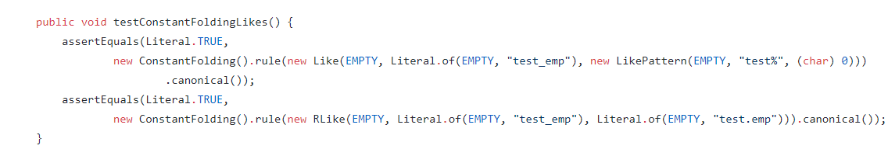

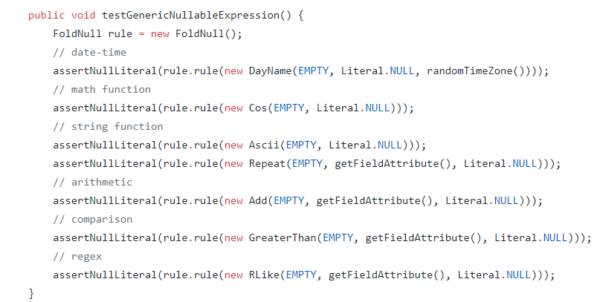



1. **System Architecture**

Researching on the open source project ElasticSearch gave us the knowledge of how this issue happens. This issue’s architecture has the following UML:

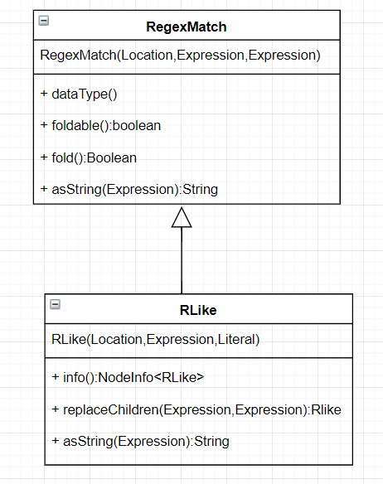

1. **Design of the fix**

Our plan to fix this issue is to create some tests for the class RLike.

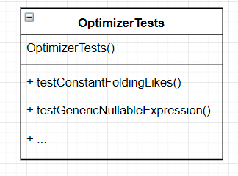

In the class **OptimizerTests** and in the file /…/**filter.sql-spec** there will be added tests to ensure that nothing breaks in the meantime.